**C:\Users\kyla coulman\AppData\Local\Microsoft\Windows\Temporary Internet Files\Content.IE5\CEFT5IFC\MC900203156[1].wmf Bleepin’ Bleep: A Mini-Tutorial about Inappropriate Language In and Out of Text**

*%@&!!

**Where do we see or hear curse words?**

*Cursing started out literally as something you would impulsively say to your neighbor if he or she had done something truly horrible to you. For instance, if he or she had stolen a goat, you might curse him or her with an extra cold winter, or a premature bald spot. It’s not very nice to wish a person a negative experience, but you might have felt better about your stolen goat, thinking the universe was in sync with your desires.*

*Pretty mild though, right?*

*Swearing evolved from complicated verbal threats to neighbors to impulsively shouted vulgar words or phrases when some people injured themselves or experienced intense frustration or anger. This particular practice of swearing became common at one point. We whine and hurt ourselves* ***a lot*** *it seems. We also see cursing in poems, novels, short stories, essays, and song lyrics.*

**What do I need to know about foul language in literature and text?**

*When someone swears after bashing a thumb with a hammer, we are being* ***impulsive****. This means that we are reacting immediately, without thought to whom or what is around us.*

*Because of the effort that goes into text creation, swearing in text is not done without thought. A writer chooses language for a deliberate or* ***created effect*** *to provide information**about*

* *a character, the speaker, a subject, or a person; this could be in reference to personality traits, feelings or emotions, beliefs, behavior, religion, or culture*
* *the mood or atmosphere of the piece; is it suspenseful? tense? What is the effect on the listener or viewer?*
* *the* ***tone*** *of the piece; what attitude (sincere, insincere, friendly, aggressive, formal, informal ) do the words communicate about an issue addressed in the plot?*

***However****, swearing is* ***not always*** *used in a deliberate way. Sometimes it is used* ***gratuitously*** *to “decorate” a conversation or song-lyric, or to act as unnecessary “filler”. It is important to be able to distinguish between a* ***deliberately chosen*** *swear with purpose and effect, and an* ***impulsive*** *swear with no effect or purpose.*

**What about Me?**

*Not everybody uses vulgar language. The* ***context*** *in which it is said determines its effect.*

**Whoops! Are there places or situations in which I shouldn’t swear?**

* *Swearing should be avoided in public places, such as school (unless it is a topic of study), work, and formal settings. It’s difficult to know who is listening and how they may react. Being disrespectful of others issues an invitation for others to be disrespectful towards you. Swearing in public has legal repercussions.*
* *For the same reason, swearing online should be avoided. Think about what is “public” and what is “private” online. A person who swears on another person’s Facebook Wall is basically shouting for attention in a room full of strangers. Think about who your audience is and consider the kind of attention you invite to yourself. What impression do you want to make on people who don’t know you?*
* *If feeling impulsive in a face to face, online, or texting situation, you would be wise to remove yourself from the situation before you say anything. Take a breather, and think about a calmer way to get your point across maturely, effectively, and respectfully. An inappropriate reaction is impossible to take back.*
* *Replace swear words in a written or spoken sentence with a more* ***appropriate word****. Effective communication entices people to read from beginning to end; swearing shocks a reader, who stops reading and your message is lost.*
* ***Consider*** *your intentions when speaking in various situations. Is your intent clear? Swearing can sometimes distract people from your true intentions or motives.*
* *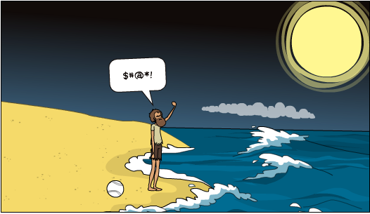Swearing can relieve pressure or stress, or give you a rebellious little thrill, but* ***don’t swear at, or around, people.*** *This is the best way to avoid trouble altogether. If you must, swear at a field, a plant, a pillow, in a vehicle (windows up!), in the middle of the forest, towards outer space, in a journal or diary, or a 1-party video game. Just don’t be surprised when someone yells at you from the wilderness to watch your language!*